The Creator

Team: Jeff Guo, Anthony Venturella, Sean Ennis

|  |  |
| --- | --- |
| Version Control | <https://github.com/JGuo99/cs426_The_Creator_Asgn6.git> |
| Bug Tracker | Github |
| Game Idea and Formal Elements | [Presentation Slides](https://docs.google.com/presentation/d/1FsrViMHNxgWDwLg5wbkz2ydFzUtcaItCnEiFVl8_TC4/edit?usp=sharing) |
| Task Manager and Calendar | Github Milestone |

**Overview:**

This is a player vs game interaction where the conflict is created by the player itself. Players will be placing planets along with setting the orbitals and select what to evolve first on habitable planets.

**Audience/Platform/Marketing:**

* Target Audience will be male and female that are over the age of 18
* This game will be developed for the desktop environment

**Characters:**

* There will only be one player itself along with AI characters.
* There are animated NPC’s on the planets to later showcase what evolution stage the planet is on.
* There’s a spaceship flying from planet to planet
* There’s a spaceship navigating through the asteroid belt

**Story:**

The higher being who created the original universe is now passing away. The player who is the descendant of the higher being is now tasked to continue the legacy of his/her predecessor.

**World:**

* Players will not be restricted to an area. They are able to move freely throughout the universe.
* There will be zones which are the planetary systems that the players can teleport to.

**Media List:**

* Sound Effects
* Thunder when near the gas planet
* Lava sound when near the lava planet
* Nature sound when near the terra planet

**Gameplay:**

**Prototype[Pre Alpha 1]:**

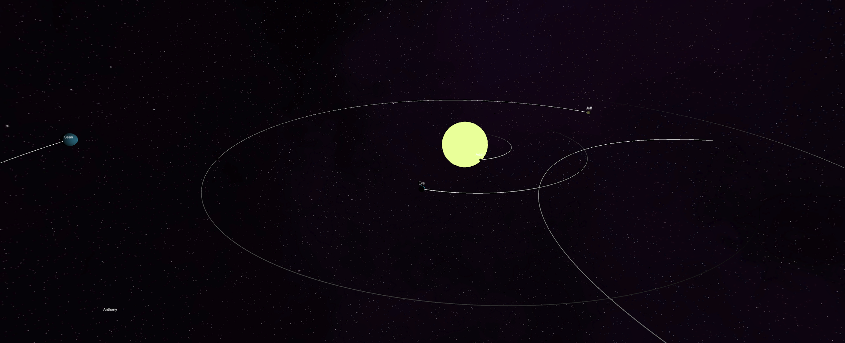

**Pre Alpha 2:**

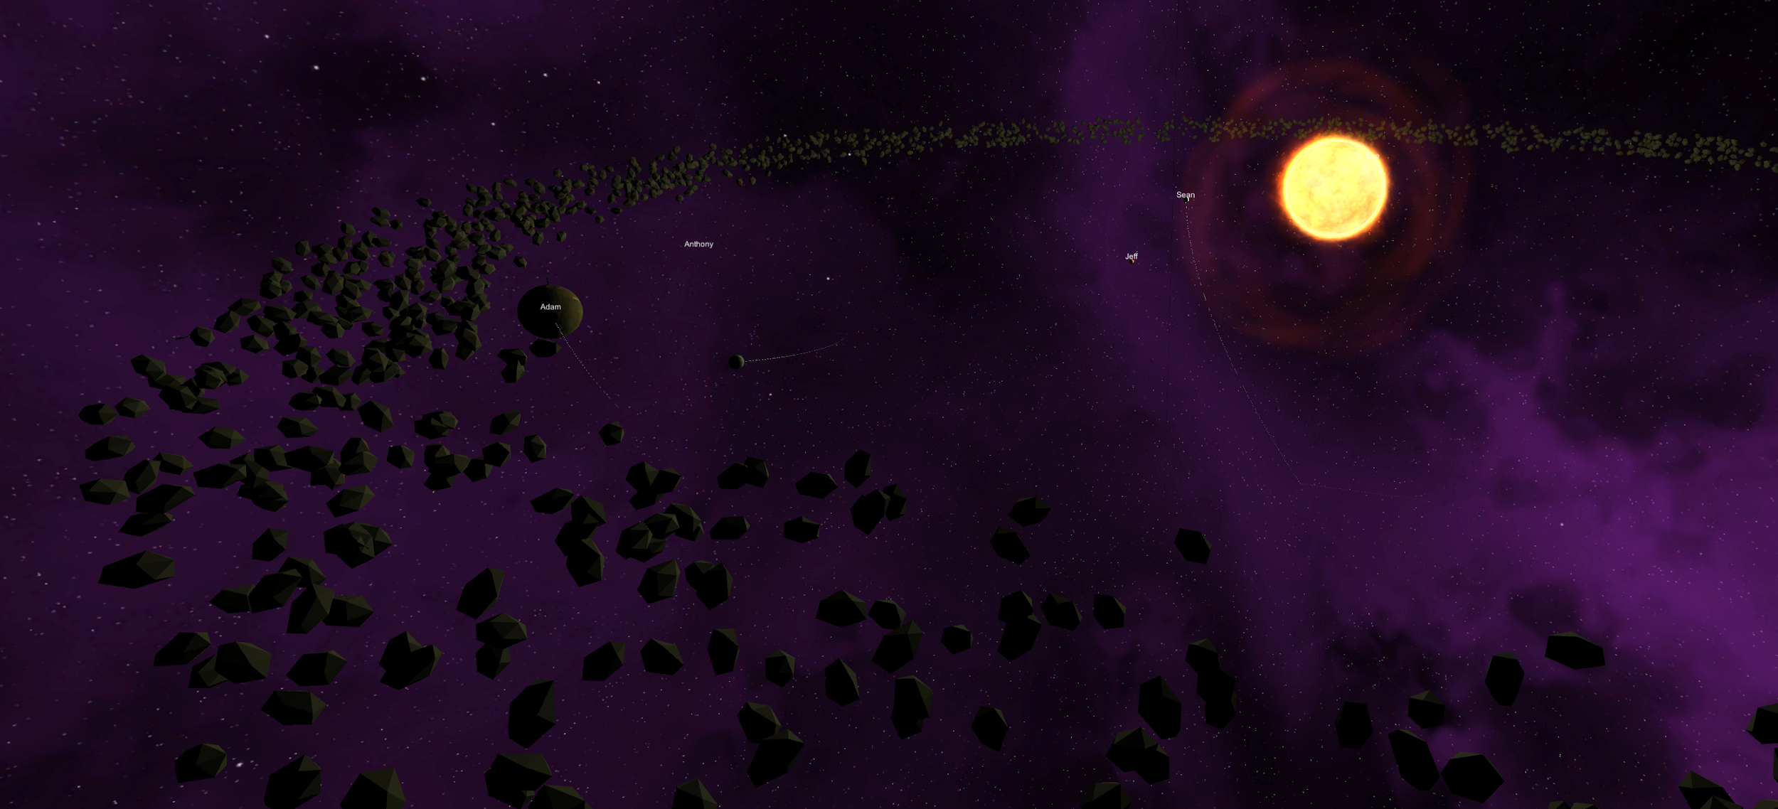

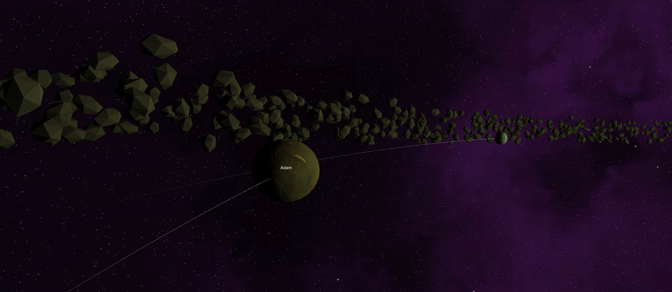

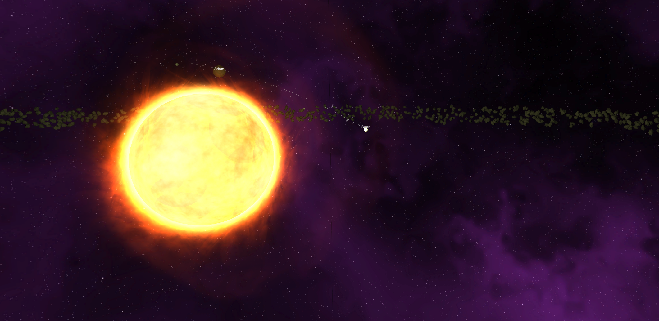

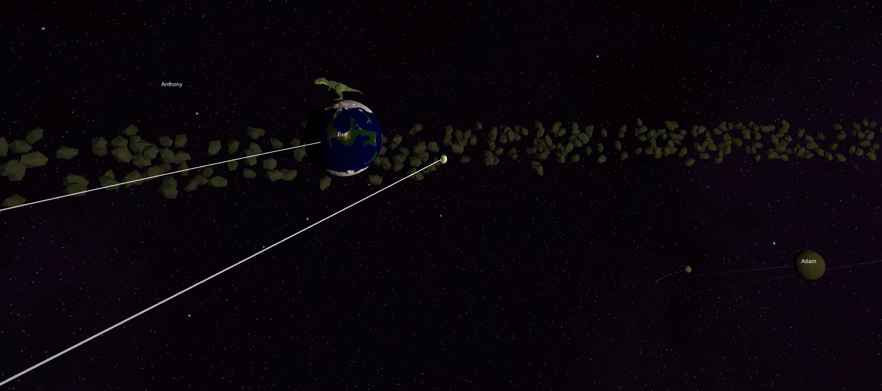

**Level Design:**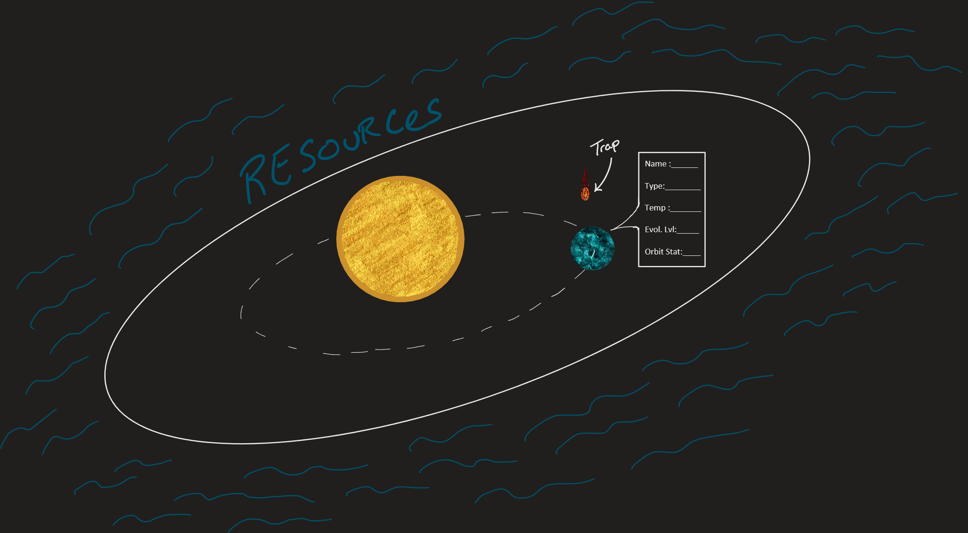

**Level Design Principle:**

**FloorPlan:**

The floorplan consists of a planetary system where the player interacts with celestial objects such as the sun, planets, moons, asteroids, etc. The Player can move out of the planetary system and enter deep space where they are able to gather resources for use in building/improving planets. When the player collects enough resources, the player could select a type of planet and its properties and then set the initial trajectory of its orbit. The planet will be affected by the gravitational pull of the other objects in space. There is no limit to the number of bodies in the planetary system.

**Traps:**

The traps consist of asteroids that randomly enter the planetary systems and cause destruction on the planets. There are also orphan planets that can enter the system and alter the planet's orbits with their gravitational pull, which in turn can cause life on that planet to be wiped out. The player can protect the planets from outside incoming objects by clicking on them in time. This will also give the player resources from the asteroids. The planets are also always in danger of colliding with one another if the orbits are done poorly, and this would cause them to be destroyed.

**Level Components:**

**Puzzles:**

Players will be solving puzzles like setting orbits, avoiding planetary collisions, maintaining evolution, and healthy status of the planet. Evolution and health of the planets can be determined based on their safety from other bodies and whether the planet is located within the Goldilock zone (if it's habitable). Later in the game players will be solving puzzles that are generated by them like what/where to gather the materials and what planets they might have to give up on for others to survive. Any resources gathered can be used to evolve the planets as well as build new ones.

**Level Geometry:**

* Planets
* Stars (Sun like)
* Asteroids
* Gas body

**Characters and Topology for animation:**

* Planets will orbit around a Star
* Planets rotation
* Characters will be bounded by the size we set for the universe
* Player is restricted from entering the planets

**Character Animations:**

* Player flies around in 3 dimensional space
* Player controls a camera that they use to observe and manipulate the planetary systems
* No physical player model/animations
* Alien suffering and dying on the lava planet
* Alien dancing on another planet
* Dinosaur defending itself on the terra planet
* Spaceship flying from planet to planet and another spaceship flying through the asteroid belt avoiding the objects

**Animations:**

* Planets rotation
* Planet evolution growth
* Flying asteroids
* Sun (Solar Flares)

**Physics:**

* The planets are set in calculated elliptical orbits revolving around the star.
* The comet has a tail when it gets close to the star and uses a particle system.
* There’s an asteroid belt that revolves around the star.
* The star has solar flares using particle physics.